**Exercise 1: Configuring a Basic Spring Application**

**App.java**

package com.library;

import com.library.service.BookService;

import org.springframework.context.ApplicationContext;

import org.springframework.context.support.ClassPathXmlApplicationContext;

public class App {

    public static void main(String[] args) {

        ApplicationContext context = new ClassPathXmlApplicationContext("applicationContext.xml");

        BookService bookService = (BookService) context.getBean("bookService");

        bookService.addBook("Spring in Action");

    }

}

**BookRepository.java**

package com.library.repository;

public class BookRepository {

    public void saveBook(String book) {

        System.out.println("Book saved: " + book);

    }

}

**BookService.java**

package com.library.service;

import com.library.repository.BookRepository;

public class BookService {

    private BookRepository bookRepository;

    // Setter for dependency injection

    public void setBookRepository(BookRepository bookRepository) {

        this.bookRepository = bookRepository;

    }

    public void addBook(String book) {

        bookRepository.saveBook(book);

    }

}

Output:

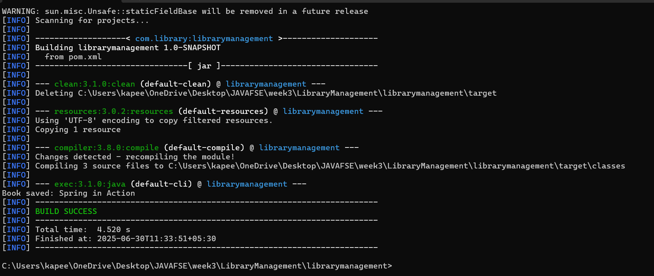

The files have to be created in the following pattern

LibraryManagement/

└── librarymanagement/

├── pom.xml

└── src/

└── main/

├── java/

│ └── com/

│ └── library/

│ ├── App.java

│ ├── service/

│ │ └── BookService.java

│ └── repository/

│ └── BookRepository.java

└── resources/

└── applicationContext.xml